
School of Engineering
IoT Systems (EG252S)
Lab 5a: Arduino with Raspberry Pi
Objectives:
- Interface Arduino with the Raspberry Pi 3.
- Reading Arduino’s Sensor Data using Raspberry Pi.
- Store Sensor Data using MySQL database.
- Collate sensor data from multiple sources using RESTful web services.
- Sending Smart Notifications from Raspberry Pi
Hardware List:
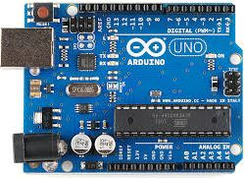  - Arduino UNO board | 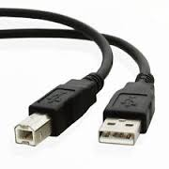  2. USB cable (Type B to Type A ) | 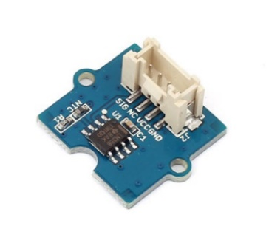  3. Grove Temp Sensor V1.2
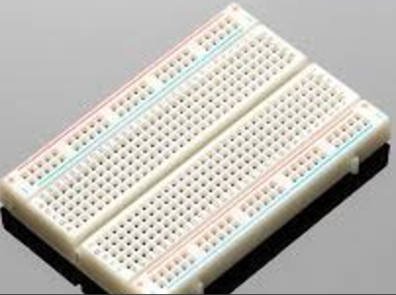  4. Breadboard | 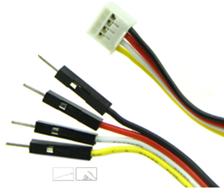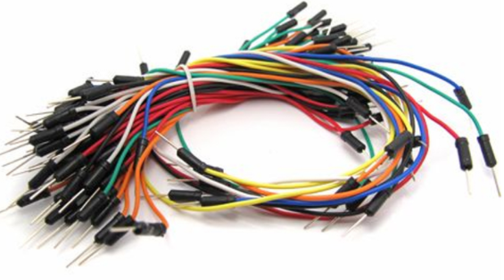  - 4-pin Grove Cable & Jumper wires | 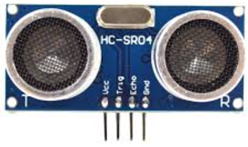  6. HC-SR04 Ultrasonic Sensor
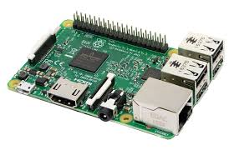  7. Raspberry Pi 3 | Software List:  - Arduino IDE software  - C Programming  - Python IDE software  - MySQL database  - phpMyAdmin  - Python Flask

Step 1 – Connect Arduino to the PC

- Start up the PC and boot into Microsoft Windows.

- Log on to the computer.

- Connect the PC to the school’s wireless network.

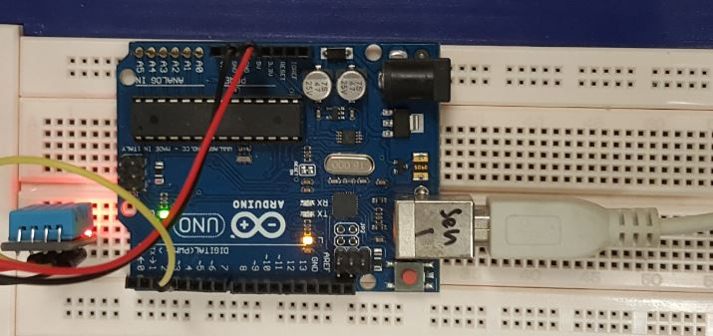
- You need to send instructions to the Arduino through the PC. We will need to first connect the Arduino to the PC using the USB cable. You can use any USB port on the PC.
USB Type A
USB Type B
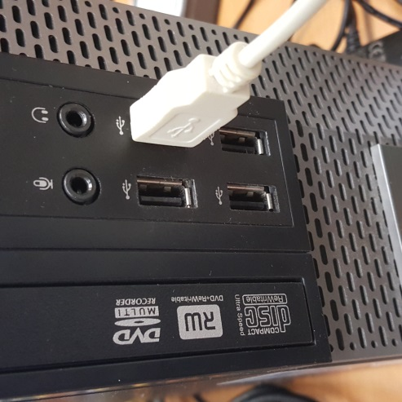
- Double click the  icon to open the Arduino IDE software. You should see something like this:
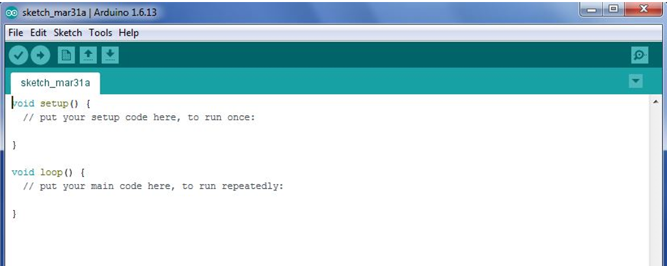

- This is where you type the code you want to compile and send to the Arduino board.

The Initial Setup

1: Check correct Arduino board being used

- As there are many hardware versions of Arduino, we should always make it a habit to check that the PC recognises the hardware we are using. To do so, click Tools Board and confirm that it recognises an Arduino Uno is connected.
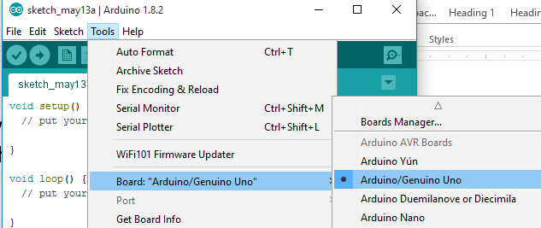

2: Check correct serial/USB communication settings between Arduino and PC

- The PC needs to send the code to the Arduino. We need to make sure both are able to recognise each other. To do so, click Tools Port. You should see a COM being used [the COM number is not important].

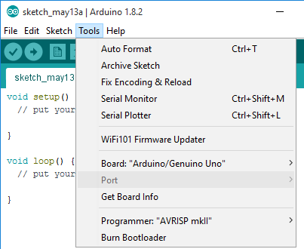  Before Arduino is plugged to PC | 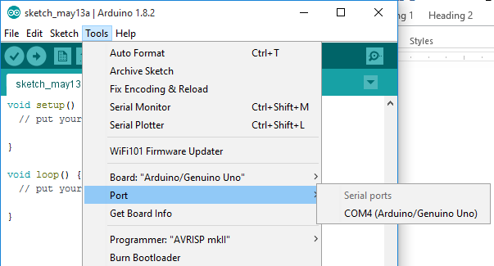  After Arduino is plugged to PC

- Select the COM port. You should see something like this.
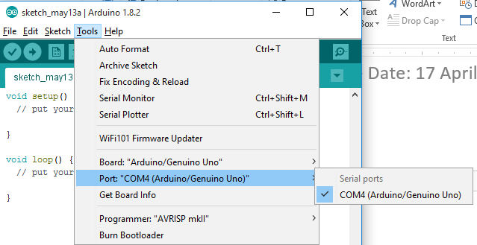

Step 2 – Connect Arduino to an Analog Temperature Sensor

Hardware Setup:

- First, let’s look at the Grove Temperature Sensor V1.2. It uses a thermistor to measure temperature. A thermistor is a resistor whose resistance changes in response to temperature. The detectable range of this sensor is -40 - 125ºC, and the accuracy is ±1.5ºC. It uses 3 pins (Vcc, GND and Signal).

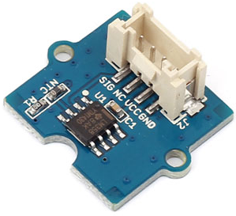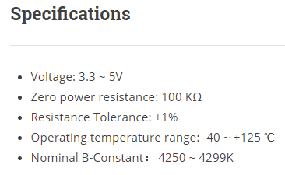

- Plug one end of the 4-pin Grove cable to the temperature sensor connector.
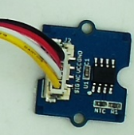

- Based on the Arduino pin out below, connect the other end of the Grove cables to the Arduino.
Arduino | Grove Cable
5V | Red | VCC
GND | Black | GND
- | White | NC (not connect)
A0 | Yellow | SIC

- We need a few VCC (5V) and GND pins connection to the Arduino (for later use). So we will use the breadboard to create a row of Vcc(5V) pins and a row of GND pins (aka power rails).

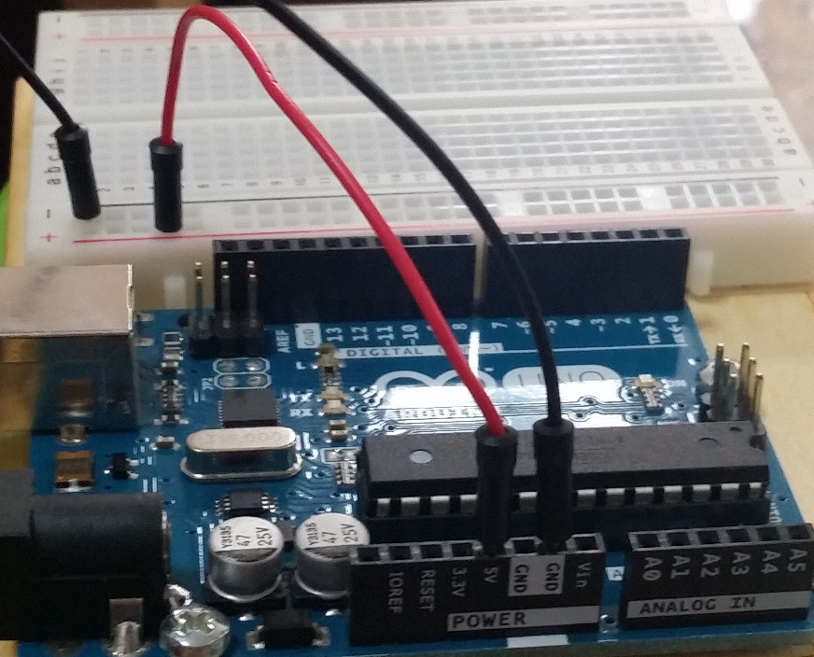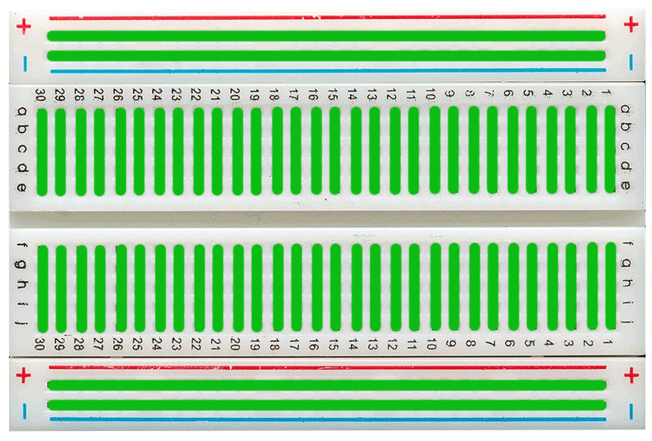
BB row/column connections

Software Setup:

- In the Arduino IDE, go to File New to create a new project, copy and paste the following code.

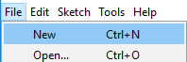

- This is the Arduino program for reading analog sensors.

#include <math.h>

const int B = 4275; // B value of the thermistor
const int R0 = 100000; // R0 = 100k
const int TempSensor = A0; // Temp Sensor connect to A0

void setup()
{
Serial.begin(9600); //to comm with Serial Monitor
}

void loop()
{
int a = analogRead(TempSensor);

float R = (1023.0/a-1.0)*R0;

// convert to deg C via datasheet
float temperature = 1.0/(log(R/R0)/B+1/298.15)-273.15;

Serial.print("Temperature = ");
Serial.println(temperature);

delay(1000);
}

- Save the sketch (program) with filename “Lab5a” and click Verify (Compile).
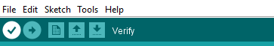

- Click  Upload to send the sketch from the PC to the Arduino.
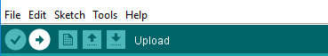

- You should see
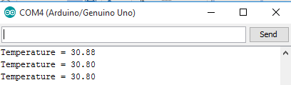

Step 3 – Connect Arduino to an Ultrasonic Sensor

Hardware Setup:

- First, let’s look at the Ultrasonic Sensor HC – SR04. It uses sonar to measure the distance to an object like how bats do. It gives 2 - 400cm of non-contact measurement with an accuracy of up to 3mm. It operation is not affected by sunlight or black material (although acoustically soft materials like cloth can be difficult to detect). It comes with an ultrasonic transmitter and a receiver module.

There are only 4 pins: VCC (Power), Trig (Trigger), Echo (Receive), and GND (Ground).

It emits an ultrasound at 40 kHz that travels through the air and if there is an object in its path, it will be reflected back to the receiver. If you can measure the time between sending the signal and receiving the reflection (echo), you can calculate the distance since speed of sound is known.
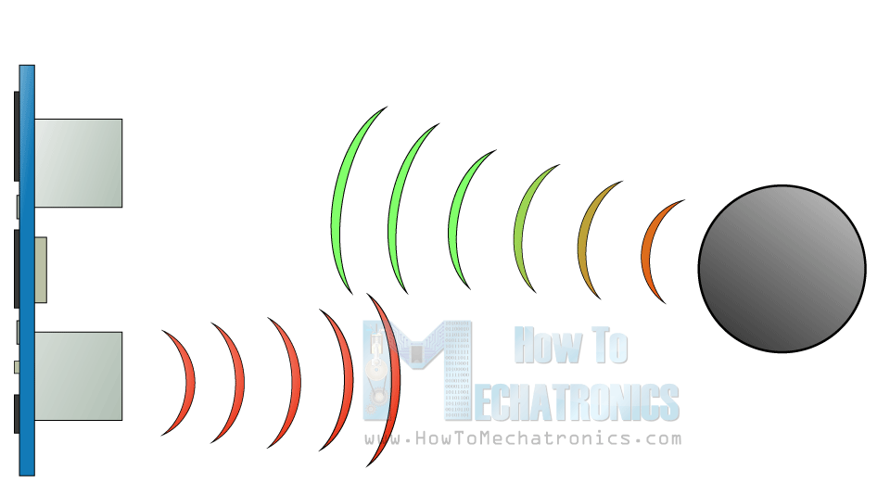
In order to generate the ultrasound, you need to set the Trig on a High State for 10 µs. That will send out an 8 cycle sonic burst which will travel at the speed of sound and it will be reflected by the object and received back at the Echo pin. The Echo pin will measure and output the time in microseconds the sound wave used to travel to and back.
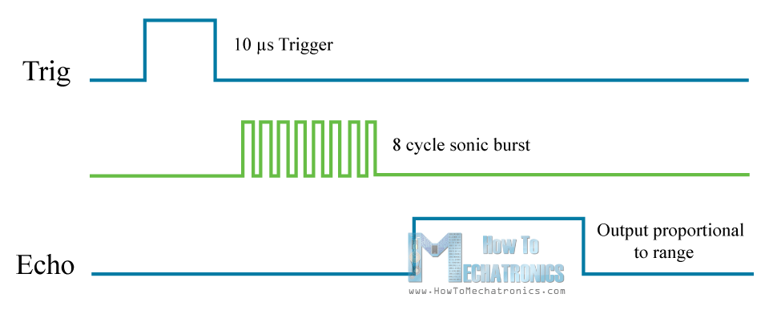

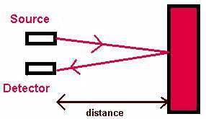
Sound travels at 340m/s or 34000cm/s.
In 1 sec 34000 cm travelled
Since 1 sec = 1,000,000 microseconds (µs),
In 1 µs 0.034 cm travelled
E.g. if an object is distance d cm away from the sensor, the time you get from the Echo pin will be the time the sound wave travels distance 2d cm (it needs to travel forward and backward). So to calculate the distance d (in cm), we need to divide the echo time by 2 and multiply by 0.034.
Reference: http://howtomechatronics.com/tutorials/arduino/ultrasonic-sensor-hc-sr04/

- Based on the schematic, connect the Ultrasonic sensor to your existing Arduino.

Please do not dismantle the previous connections.

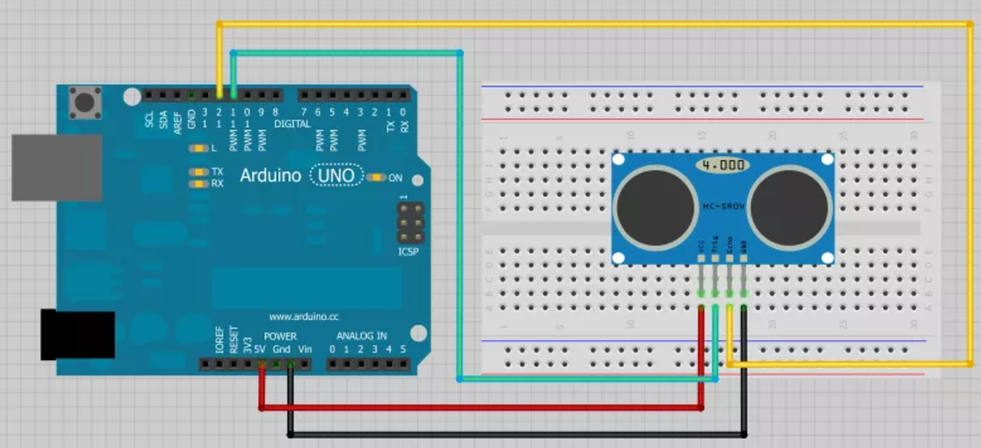
Arduino | Ultrasonic Sensor
5V | Red | VCC
D11 | Green | Trigger
D12 | Yellow | Echo
GND | Black | GND

Software Setup:

First, need to define the Trig and Echo pins. We are using pins 9 and 10 and they are named trigPin and echoPin. The trigPin will be an output (sending out the ultrasound wave) and echoPin is an input (receiving the echo).
A Long variable, named “duration”, will store the travel time you get from the sensor.
In the loop() function, we will need to send a HIGH to the trigPin to trigger it to send out a ultrasound. But before this, we need to ensure that trigPin is not in an undefined state so we will first SET it to a LOW state (for just 2 µs). Then generate the ultrasound by setting the trigPin on HIGH State for 10 µs.
The pulseIn() function will give you the time (in µs) between sending the trigger ultrasound and receiving the echo. This function has 2 parameters, the first one is the name of the echo pin and for the second one you can use either HIGH or LOW. A HIGH means that the pulseIn() function will wait for the pin to go HIGH, starts timing, then it will wait for the pin to go LOW and stop the timing. To get the distance, we will divide the time by 2 and multiply the duration by 0.034.
- In the Arduino IDE, go to File New to create a new project, copy and paste the following code.

- This is the Arduino program for displaying both Analog Temperature and Ultrasonic Sensor Readings on the Serial Monitor.

#include <math.h>

//For Temp sensor
const int B = 4275; // B value of the thermistor
const int R0 = 100000; // R0 = 100k
const int TempSensor = A0; // Temp Sensor connect to A0

// For Ultrasonic sensor; defines pins numbers
const int trigPin = 11;
const int echoPin = 12;

// defines global variables
long duration;
int distance;

void setup()
{
pinMode(trigPin, OUTPUT); // Sets the trigPin as an Output
pinMode(echoPin, INPUT); // Sets the echoPin as an Input

Serial.begin(9600); // Starts the serial communication
}

void loop()
{
//To read analog temp sensor
int a = analogRead(TempSensor);
float R = (1023.0/a-1.0)*R0;
// convert to deg C via datasheet
float temperature = 1.0/(log(R/R0)/B+1/298.15)-273.15;

//Serial.print("Temperature (degC) = ");
Serial.println(temperature);

// Clears the trigPin
digitalWrite(trigPin, LOW);
delayMicroseconds(2);

// Sets the trigPin on HIGH state for 10 micro seconds
digitalWrite(trigPin, HIGH);
delayMicroseconds(10);

// Reads the echoPin, returns the ultrasound wave travel time in microsec
duration = pulseIn(echoPin, HIGH);

// Calculating the distance
distance= duration*0.034/2;

// Prints the distance on the Serial Monitor
//Serial.print ("Distance(cm): ");
Serial.println(distance);
delay(3000);
}

- Save the sketch (program) with filename “Lab5b” and click Verify (Compile).

- Click Upload to send the sketch from the PC to the Arduino.

- You should see something like this, depending on what the sensor sensed.
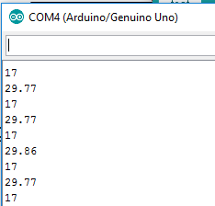

Step 4 – Preparing the Raspberry Pi

Hardware Setup:

- Connect the USB keyboard and mouse to the RPi.

- Connect the RPi to the PC monitor via the HDMI-VGA adapter. You will be sharing the PC monitor between the PC and RPi.

- Connect power supply to the RPi via the micro USB connector.

- We will use a new SD card. Insert the SD card into RPi,

- Power on the RPi. You will need to install the Raspbian OS. Check the box and click Install.
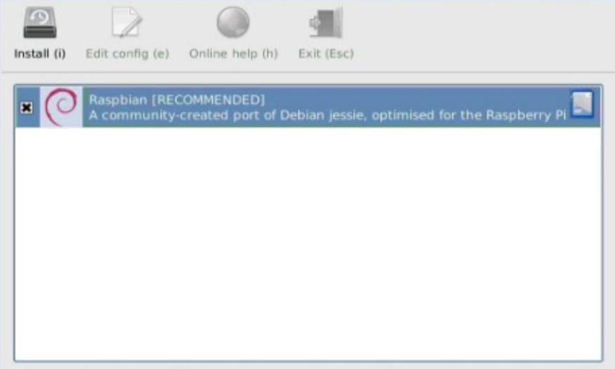

- You should eventually see this screen.
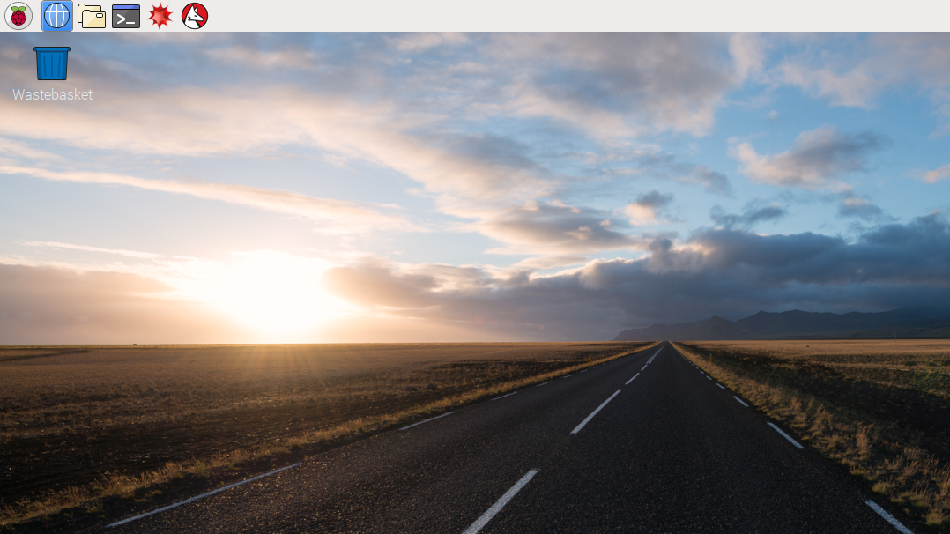

Internet Connection Setup:

- We need to set up an Internet connection for the RPi as follows.
- Click the Terminal  icon on the top left menu bar. This is where we send instructions to the RPi.
- We can scan for Wi-Fi networks with the command.

pi@raspberrypi:~$ sudo iwlist wlan0 scan

Check that the “NYP-Student” wifi network is available for connection:
Cell xx – Address: F0:B4:29:50:76:0C
ESSID: “NYP-Student”
Mode: Master_Channel: 1
…

- To minimize typos, we will cut and paste the configuration into the Raspberry Pi. Please select all the text in the box below and copy into Notepad.

country=SG
ctrl_interface=DIR=/var/run/wpa_supplicant GROUP=netdev
update_config=1

network={

ssid="NYP-Student"
scan_ssid=1
proto=RSN
key_mgmt=WPA-EAP
pairwise=CCMP TKIP
group=CCMP TKIP
identity="StudentPortalUsername "
password="StudentPortalPassword "
phase1="peapver=1"
phase2="auth=MSCHAPV2"
}

iface wlan0 inet dhcp
pre-up wpa_supplicant -B -Dwext -i wlan0 -c /etc/wpa_supplicant/wpa_supplicant.conf post-down killall -q wpa_supplicant
- Save the notepad file with the name “wpa.txt” into a USB thumb drive.
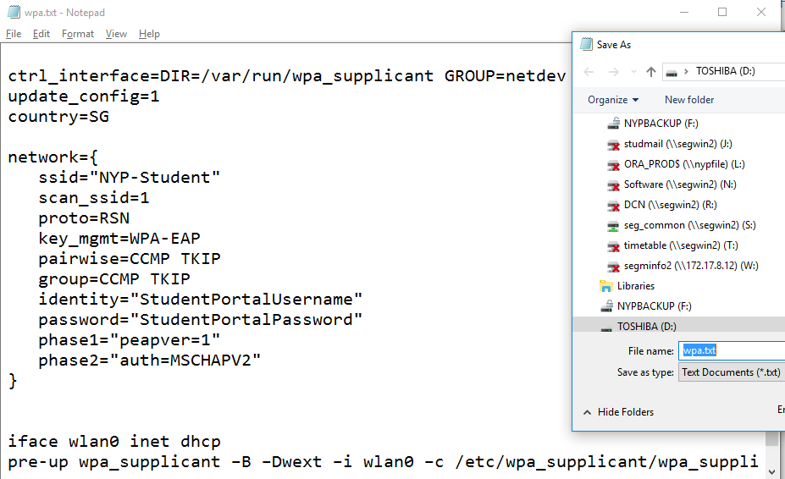

- Insert the thumb drive into the RPI. RPI will detect the thumb drive. Click “OK”.
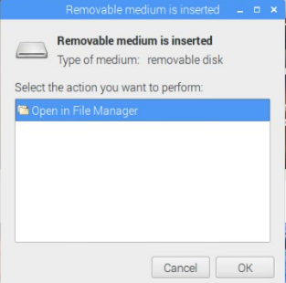

- From RPI, browse to the thumb drive, highlight and double click “wpa.txt”.
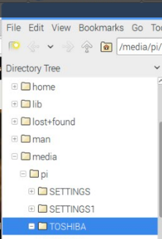
- Copy “Part 1” text by highlighting the text and press “Ctrl-C”.

country=SG
ctrl_interface=DIR=/var/run/wpa_supplicant GROUP=netdev
update_config=1
Part 1
network={

ssid="NYP-Student"
scan_ssid=1
proto=RSN
key_mgmt=WPA-EAP
pairwise=CCMP TKIP
group=CCMP TKIP
identity="StudentPortalUsername "
password="StudentPortalPassword "
phase1="peapver=1"
phase2="auth=MSCHAPV2"
}

iface wlan0 inet dhcp
pre-up wpa_supplicant -B -Dwext -i wlan0 -c /etc/wpa_supplicant/wpa_supplicant.conf post-down killall -q wpa_supplicant

- We will now add the Wi-Fi settings to the wpa-supplicant config file. Type the following

pi@raspberrypi:~$ sudo nano /etc/wpa_supplicant/wpa_supplicant.conf

- Delete everything.

- Click Edit Paste to paste “Part 1” into the configuration file.

For reference: https://www.freebsd.org/cgi/man.cgi?wpa_supplicant.conf
- ssid - name of SSID
- psk – pre-share key
- proto - either RSN (WPA2) or WPA (WPA1).
- key_mgmt - either WPA-PSK (most probably) or WPA-EAP (enterprise networks)
- pairwise - either CCMP (WPA2) or TKIP (WPA1)
- group - either CCMP (WPA2) or TKIP (WPA1)

- Save the file by pressing CTRL+X and then Y on the keyboard. Press enter to confirm.

- Instead of exposing your password in plaintext, we will secure it by using a hashed version of your password. Typing this will create a password hash and will save it to “hash.txt”.

pi@raspberrypi:~$ echo -n 'password_in_plaintext' | iconv -t utf16le | openssl md4 > hash.txt

- Now open “hash.txt” by typing the following.

pi@raspberrypi:~$ nano hash.txt

- It should look something like this. Highlight the password.

(stdin)= a6fsfs71xxxxxxxxxxxxxxxetcetcetc

- Click EditCopy. This will copy the hashed password.

- Exit the file by pressing CTRL+X. Press enter.

- Open wifi config file (wpa_supplicant.conf) by typing the following.

pi@raspberrypi:~$ sudo nano /etc/wpa_supplicant/wpa_supplicant.conf

- Position the cursor next to the password field and type “hash:”. Paste the hashed password into the password field of the file as shown below.

…
identity="StudentPortalUsername"
password=hash:a6fsfs71xxxxxxxxxxxxxxxetcetcetc
…

- Save the file by pressing CTRL+X and then Y on the keyboard. Press enter to confirm.

- Now, delete plaintext password by typing “history” and look for the associated line number. We will delete the associated line number.

pi@raspberrypi:~$ history
251 echo -n 'plaintextpassword' | iconv -t utf16le | openssl md4 > hash.txt
pi@raspberrypi:~$ history –d 251

- Go to “wpa.txt”. Copy “Part 2” text by highlighting the text and press “Ctrl-C”.
Part 2

iface wlan0 inet dhcp
pre-up/wpa_supplicant -B -Dwext -i wlan0 -c /etc/wpa_supplicant/wpa_supplicant.conf post-down killall -q wpa_supplicant

- You will need to make sure Wifi is on DHCP. Type the following

pi@raspberrypi:~$ sudo nano /etc/network/interfaces

- Position cursor at the wlan0 section. Click Edit Paste to paste “Part 2” into the configuration file.

auto lo
iface lo inet loopback

iface eth0 inet manual

allow-hotplug wlan0
iface wlan0 inet dhcp
pre-up wpa_supplicant –B –Dwext –i wlan0 –c /etc/wpa_supplicant/wpa_supplicant.conf
post-down killall –q wpa_supplicant [1 line]

- Now, need to activate the settings by restarting the network service by typing

pi@raspberrypi:~$ sudo systemctl restart networking.service

- Check if RPi has a IP address and connected to the Wi-Fi by typing

pi@raspberrypi:~$ ifconfig wlan0

- If there is no IP address, then do the following

pi@raspberrypi:~$ sudo ifdown wlan0
pi@raspberrypi:~$ sudo ifup wlan0

or

pi@raspberrypi:~$ sudo ip addr flush wlan0
pi@raspberrypi:~$ sudo systemctl restart networking

- If it still does not get any IP, restart the RPi by typing

pi@raspberrypi:~$ sudo reboot
Remote Access Tools Setup:

- Next, we will install remote access tools in RPi to access it via Windows Remote Desktop. Type the following

pi@raspberrypi:~$ sudo apt-get install xrdp -y
Step #1
Reading package lists…done
Building dependency tree
…
After this operation, 10.0MB of additional disk space will be used.
Get:1 http://mirrordirector.raspbian.org/...
…
Processing triggers for …

pi@raspberrypi:~$ sudo apt-get install vnc4server -y
Step #2
Reading package lists…done
Building dependency tree
…
After this operation, 21.1MB disk space will be freed.
Get:1 http://mirrordirector.raspbian.org/...
…
Setting up xbitmaps…

pi@raspberrypi:~$ sudo systemctl restart xrdp.service
Step #3
or

pi@raspberrypi:~$ sudo service xrdp restart

- You can go back to the Windows Desktop and connect to RPI using Windows Remote Desktop.

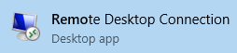
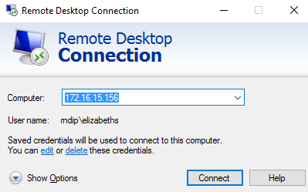
- Enter the RPI’s IP address. Click “Connect”.

- Click “Connect”.

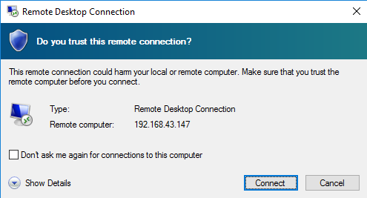

- Click “Yes”.

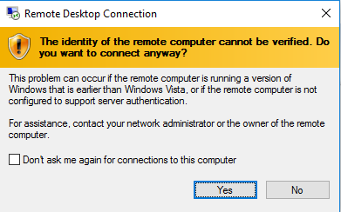

- Enter username = “pi”, password=”raspberry”. Click “OK”.

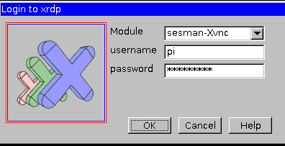

- You can now see RPI on your Windows Desktop.

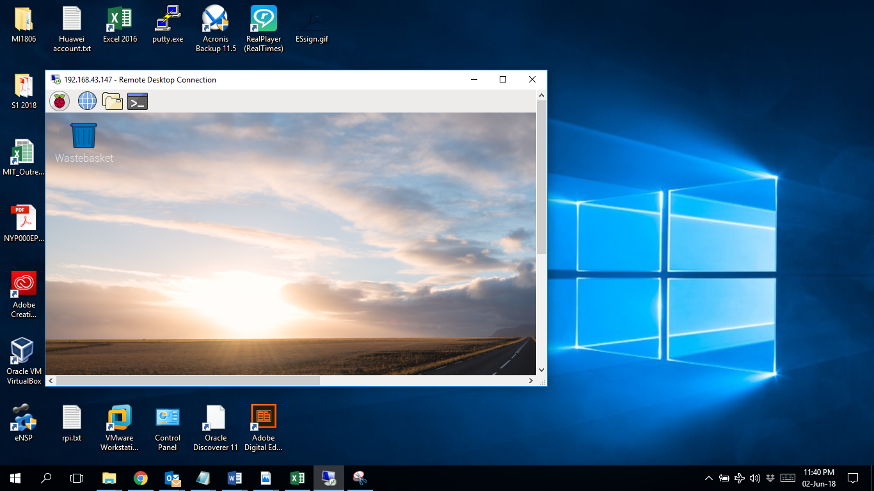

- From the RPI remote desktop, go to Terminal to continue with the configuration.

TimeZone Setup:

- The Date and Time in a new clean install of Raspbian needs to be updated to your current Time Zone. Type the following

pi@raspberrypi:~$ sudo raspi-config

Go to Internationalisation Options Change Timezone Asia Singapore.

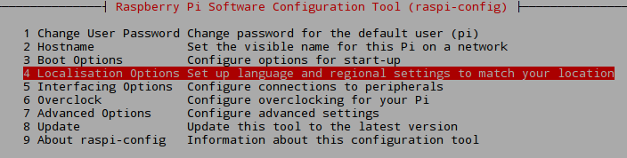

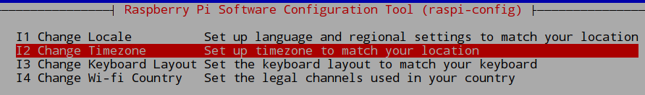

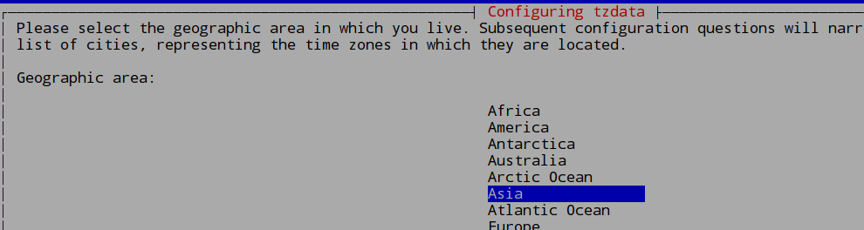

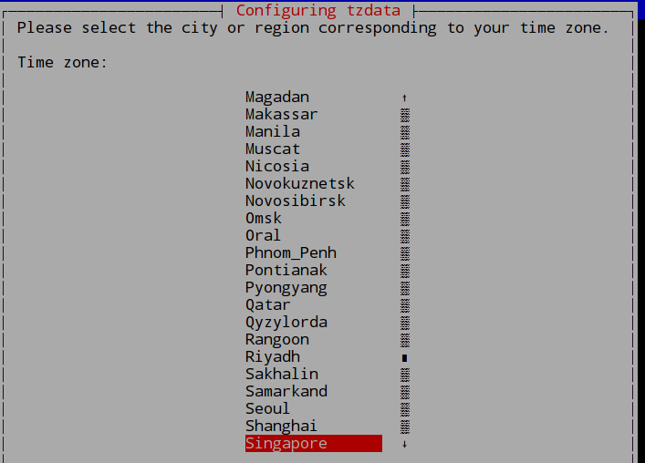
- Tab to Finish and press “Enter”.

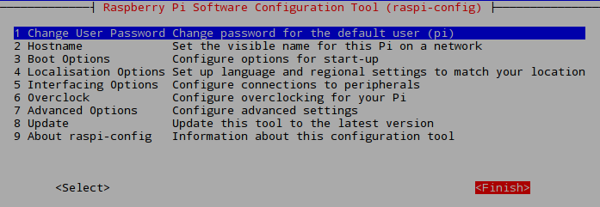

- Reboot RPi by

pi@raspberrypi:~$ sudo reboot

- After rebooting, check the date/time by typing

pi@raspberrypi:~$ date

Mon 19 Jun 12:30:45 SGT 2017

- Now change the date by typing the following

pi@raspberrypi:~$ sudo date –s “Jun 22 13:30 SGT 2018”
Use Current Time
Fri 22 Jun 13:30:00 SGT 2018

Software Installation:
  - LAMP (Linux, Apache, MySQL and PHP)
  - phpMyAdmin

- First do a software update by typing

pi@raspberrypi:~$ sudo apt-get update

Get:1 http://mirrordirector.raspbian.org jessie InRelease [14.9 kB]
Get:2 http://archive.raspberrypi.org jessie InRelease [22.9 kB]
Get:3 http://mirrordirector.raspbian.org jessie/main armhf Packages [9,533 kB]
…
Fetched 9,922 kB in 43s (230 kB/s)
Reading package lists... Done

- Install Apache web server by typing

pi@raspberrypi:~$ sudo apt-get install apache2 –y

Reading package lists... Done
Building dependency tree
Reading state information... Done
…
Need to get 1,758 kB of archives.
After this operation, 5,259 kB of additional disk space will be used.
Get:1 http://mirrordirector.raspbian.org/raspbian/jessie/main libapr1 armhf 1.5.1-3 [77.1 kB]
Get:2 http://mirrordirector.raspbian.org/raspbian/jessie/main libaprutil1 armhf 1.5.4-1 [75.9 kB]
Fetched 1,758 kB in 9s (181 kB/s)
Preconfiguring packages ...
…
Unpacking libapr1:armhf (1.5.1-3) ...
…
Processing triggers for systemd (215-17+deb8u5) ...

- To confirm installation, you can type

pi@raspberrypi:~$ apache2 –v

Server Version: Apache/2.4.10 (Raspbian)

- Install PHP server-side scripting language for web development by typing

pi@raspberrypi:~$ sudo apt-get install php5 –y

Reading package lists... Done
Building dependency tree
Reading state information... Done
…
Need to get 5,087 kB of archives.
After this operation, 18.8MB of additional disk space will be used.
Get:1 http://mirrordirector.raspbian.org/raspbian/jessie/main libapr1 armhf 1.5.1-3 [77.1 kB]
Get:2 http://mirrordirector.raspbian.org/raspbian/jessie/main libaprutil1 armhf 1.5.4-1 [75.9 kB]
Fetched 5,087 kB in 17s (293 kB/s)
…
Unpacking libapr1:armhf (1.5.1-3) ...
…
Processing triggers for libapache2-mod-php5 (5.6.30+dfsg-0+deb8u1) ...

- To confirm installation, you can type

pi@raspberrypi:~$ php –v

PHP 5.6.33-0+deb8u1 (cli) (built: Jan 9 2018 16:20:58)

- Install MySQL database by typing

pi@raspberrypi:~$ sudo apt-get install mysql-server –y

Reading package lists... Done
Building dependency tree
Reading state information... Done
…
Need to get 8,343 kB of archives.
After this operation, 89.4MB of additional disk space will be used.
Get:1 http://mirrordirector.raspbian.org/raspbian/jessie/main libaio1 armhf 0.3.110-1 [9,228 B]
Get:2 http://mirrordirector.raspbian.org/raspbian/jessie/main mysql-common all 5.5.55-0+deb8u1[86.0 kB]
Fetched 8,343 kB in 21s (395 kB/s)
Preconfiguring packages ...
…
Unpacking libaio1:armhf (0.3.110-1) …
Setting up mysql-client-5.5 (5.5.55-0+deb8u1) ......

- You will be prompted for a password, type “admin”.

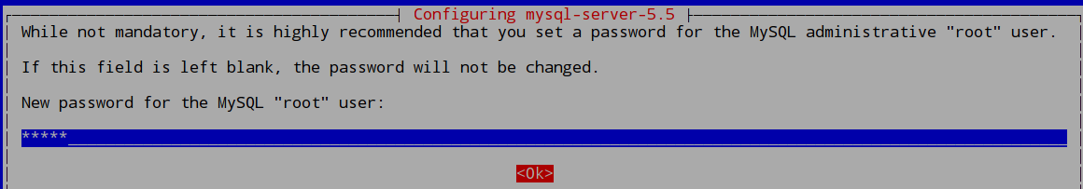

- Re-type the password “admin” for confirmation.

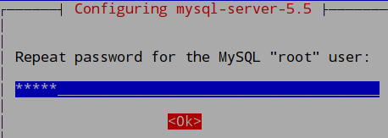

- To check if MySQL is running, you can type

pi@raspberrypi:~$ sudo systemctl status mysql.service

mysql.service - LSB: Start and stop the mysql database server daemon
Loaded: loaded (/etc/init.d/mysql)
Active: active (running) since Sun 2017-06-25 18:29:15 SGT; 11min ago
CGroup: /system.slice/mysql.service
|--13370 /bin/sh /usr/bin/mysqld_safe
|--13716 /usr/sbin/mysqld --basedir=/usr --datadir=/var/lib/…

Jun 25 18:29:25 raspberrypi /etc/mysql/debian-start[13778]: mysql.general_log OK
Jun 25 18:29:25 raspberrypi /etc/mysql/debian-start[13778]: mysql.help_category OK
Jun 25 18:29:25 raspberrypi /etc/mysql/debian-start[13778]: mysql.help_keyword OK
Jun 25 18:29:25 raspberrypi /etc/mysql/debian-start[13778]: mysql.help_relation OK
Jun 25 18:29:25 raspberrypi /etc/mysql/debian-start[13778]: mysql.help_topic OK
Jun 25 18:29:25 raspberrypi /etc/mysql/debian-start[13778]: mysql.host OK
Jun 25 18:29:25 raspberrypi /etc/mysql/debian-start[13778]: mysql.ndb_binlog_index OK
Jun 25 18:29:25 raspberrypi /etc/mysql/debian-start[13778]: mysql.plugin OK
Jun 25 18:29:25 raspberrypi /etc/mysql/debian-start[13778]: mysql.proc OK
Jun 25 18:29:25 raspberrypi /etc/mysql/debian-start[13778]: mysql.procs_priv OK

- Congrats. You have successfully installed LAMP.

- We will proceed to install phpMyAdmin. This is to manage the MySQL database via a web interface.

pi@raspberrypi:~$ sudo apt-get install phpmyadmin -y

Reading package lists... Done
Building dependency tree
Reading state information... Done
The following extra packages will be installed:
dbconfig-common libmcrypt4 php-gettext php-tcpdf php5-gd php5-mcrypt php5-mysql
…
Need to get 12.5 MB of archives.
After this operation, 46.6 MB of additional disk space will be used.
Get:1 http://mirrordirector.raspbian.org/raspbian/jessie/main libmcrypt4 armhf 2.5.8-3.3 [64.2 kB]
Get:2 http://mirrordirector.raspbian.org/raspbian/jessie/main dbconfig-common all 1.8.47+nmu3+deb8u1 [628 kB]

Fetched 12.5 MB in 28s (435 kB/s)
Preconfiguring packages ...
…
Processing triggers for libapache2-mod-php5 (5.6.30+dfsg-0+deb8u1) ...

- The installation will prompt you to choose the web server. Tab to “apache2” and press Enter to continue.

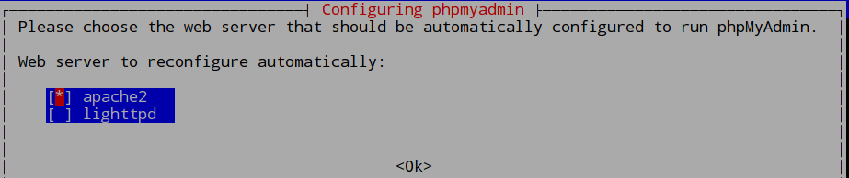

- The installation will prompt to configure a database, press Enter to accept the default “Yes”.
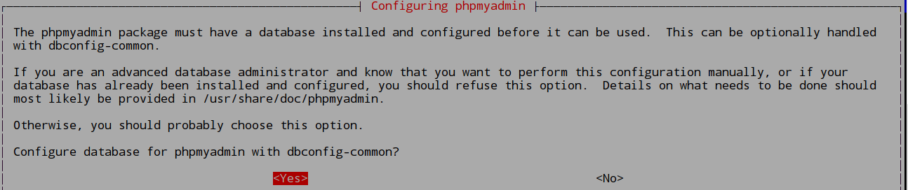

- Type “admin” to provide the password for the administrative account to the MySQL database. Press Enter to continue.

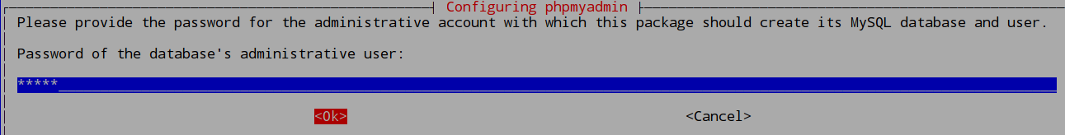

- Type “admin” as the password. Press Enter to continue.

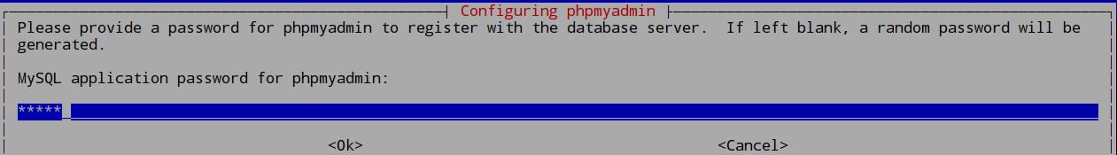

- Type “admin” as the password. Press Enter to continue.

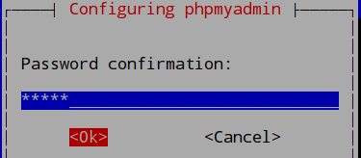

- You need to activate phpMyadmin by adding the line in green in the config file. Open the config file by typing the following

pi@raspberrypi:~$sudo nano /etc/apache2/apache2.conf

- Go to the end of the file and add the following line.

Include /etc/phpmyadmin/apache.conf

- You will need to restart the apache service for the changes to take effect. Type the following.

pi@raspberrypi:~$ sudo systemctl restart apache2.service

- Test out phpMyAdmin by going to a browser and enter http://localhost/phpmyadmin.

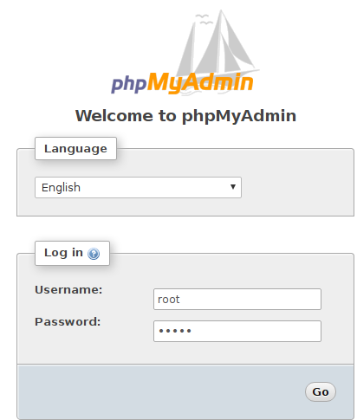
- Enter username=root, password=admin. Click ok.

- Click “Save” to save the password but note that this is not a good practice. We are only doing so as this is a lab environment.
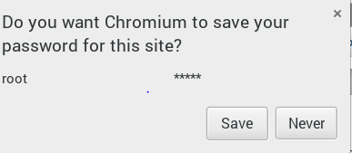

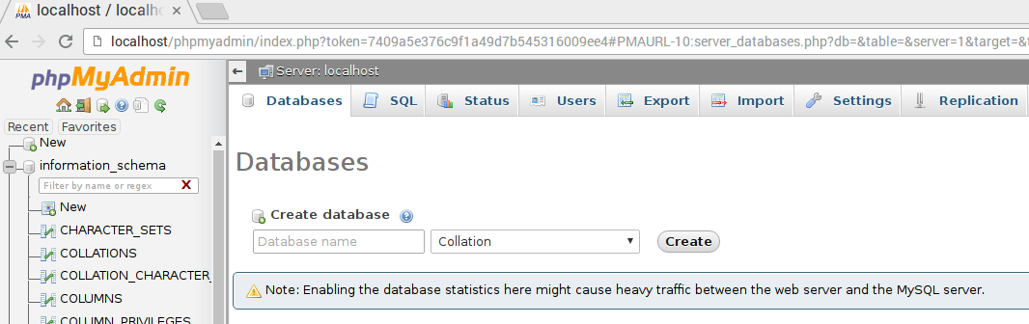
- You should see something like this.

- You have completed installing the software needed for this lab. Later on, we will still need to install python libraries that we need to use with our codes. We will install the libraries only on a need basis.
Step 5 – Using Raspberry Pi to read Arduino’s Sensor Data

Hardware Setup:

There are many ways to connect a RPi to a Arduino such as using the GPIO, serial or I2C connectors. We will use a serial USB connector for this purpose.

How RPi ‘see’ the Serial connection?

RPi use the Raspbian OS which is Linux based. Linux treats everything as a file. This means an attached CDROM is a file, the hard disk is a file and a USB connection is a file. All these files can be seen under the file system. You can open any file and will be able to read the contents of the CDROM or hard disk or USB connection for that matter.

In the /dev directory, you’ll find files that represent devices e.g. /dev/cdrom is your CD-ROM drive, /dev/sda represents your first hard drive while /dev/sda1 represents the first partition on your first hard drive. As Linux has its origins in teletypewriters (tty), it uses /dev/tty to represent many types of devices. So we must now find out which file in /dev/tty represents the Arduino’s USB connection.

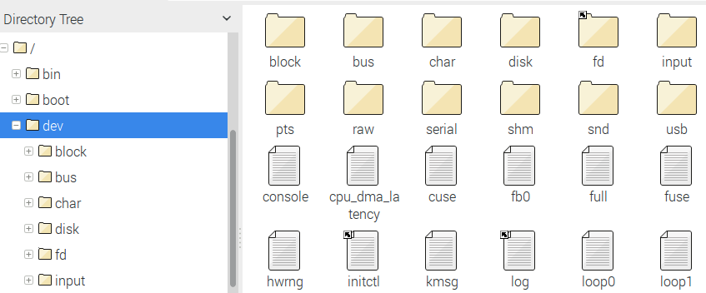

- We will first create a before USB connector device mapping by typing

pi@raspberrypi:~ $ ls /dev/tty*
/dev/tty /dev/tty19 /dev/tty3 /dev/tty40 /dev/tty51 /dev/tty62
/dev/tty0 /dev/tty2 /dev/tty30 /dev/tty41 /dev/tty52 /dev/tty63
/dev/tty1 /dev/tty20 /dev/tty31 /dev/tty42 /dev/tty53 /dev/tty7
/dev/tty10 /dev/tty21 /dev/tty32 /dev/tty43 /dev/tty54 /dev/tty8
/dev/tty11 /dev/tty22 /dev/tty33 /dev/tty44 /dev/tty55 /dev/tty9
/dev/tty12 /dev/tty23 /dev/tty34 /dev/tty45 /dev/tty56 /dev/ttyAMA0
/dev/tty13 /dev/tty24 /dev/tty35 /dev/tty46 /dev/tty57 /dev/ttyprintk
/dev/tty14 /dev/tty25 /dev/tty36 /dev/tty47 /dev/tty58
/dev/tty15 /dev/tty26 /dev/tty37 /dev/tty48 /dev/tty59
/dev/tty16 /dev/tty27 /dev/tty38 /dev/tty49 /dev/tty6
/dev/tty17 /dev/tty28 /dev/tty39 /dev/tty5 /dev/tty60
/dev/tty18 /dev/tty29 /dev/tty4 /dev/tty50 /dev/tty61

- Unplug the serial USB connector from the computer.

- Plug the USB connector into the Raspberry Pi (RPi).

- We will then repeat to create a after USB connector device mapping by typing

pi@raspberrypi:~ $ ls /dev/tty*
/dev/tty /dev/tty19 /dev/tty3 /dev/tty40 /dev/tty51 /dev/tty62
/dev/tty0 /dev/tty2 /dev/tty30 /dev/tty41 /dev/tty52 /dev/tty63
/dev/tty1 /dev/tty20 /dev/tty31 /dev/tty42 /dev/tty53 /dev/tty7
/dev/tty10 /dev/tty21 /dev/tty32 /dev/tty43 /dev/tty54 /dev/tty8
/dev/tty11 /dev/tty22 /dev/tty33 /dev/tty44 /dev/tty55 /dev/tty9
/dev/tty12 /dev/tty23 /dev/tty34 /dev/tty45 /dev/tty56 /dev/ttyACM0
/dev/tty13 /dev/tty24 /dev/tty35 /dev/tty46 /dev/tty57 /dev/ttyAMA0
/dev/tty14 /dev/tty25 /dev/tty36 /dev/tty47 /dev/tty58 /dev/ttyprintk
/dev/tty15 /dev/tty26 /dev/tty37 /dev/tty48 /dev/tty59
/dev/tty16 /dev/tty27 /dev/tty38 /dev/tty49 /dev/tty6
/dev/tty17 /dev/tty28 /dev/tty39 /dev/tty5 /dev/tty60
/dev/tty18 /dev/tty29 /dev/tty4 /dev/tty50 /dev/tty61

- By comparing, we know the Arduino USB connection is represented by the file /dev/ttyACM0.

Software Setup:

- We will now use Python to communicate with the /dev/ttyACM0 file (USB connection) to read in the sensor data.

- We will use Python 2 on Raspberry Pi.

- Go to MenuProgrammingPython 2 (IDLE). We are not using Python 3 due to library support, performance issues etc but note that support for Python ver 2.7 will cease in 2020.

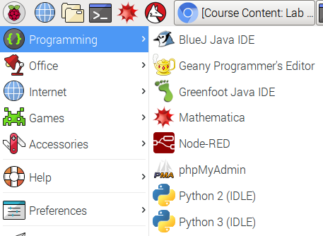

- At the Python Shell, click File New File to create a new project.

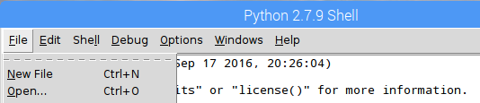

- This is the Python program for reading sensor data from the Serial USB connector. You can copy and paste (need to access Polymall [http://polymall.polytechnic.edu.sg] from within RPI and open the lab sheet). You cannot copy directly between the PC and the remote desktop.

#!/usr/bin/python

#serial comm library
import serial

#read serial data coming from Adruino
ser = serial.Serial('/dev/ttyACM0', 9600)

while True:
Temp = ser.readline() #read Temp data
Temp = Temp.rstrip('\r\n') #remove return and newline

Dist = ser.readline()
Dist = Dist.rstrip('\r\n')

print "Temperature: " + Temp + "degC"
print "Distance: " + Dist + "cm"

- Save the Python program with filename “Lab5c”. Click “Save”.
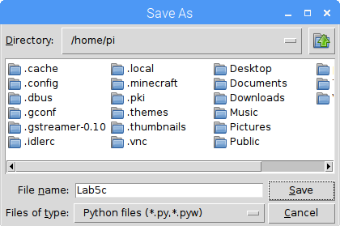

- Press F5 to run the program. You should see something like this.
